APPENDIX A
PHOTOGRAPHS TAKEN DURING JIV AT 18” TEBIDABA-BRASS PIPELINE AT LASUKUGBENE COMMUNITY, SOUTHERN IJAW L.G.A, BAYELSA STATE.ON 10TH MARCH, 2024.
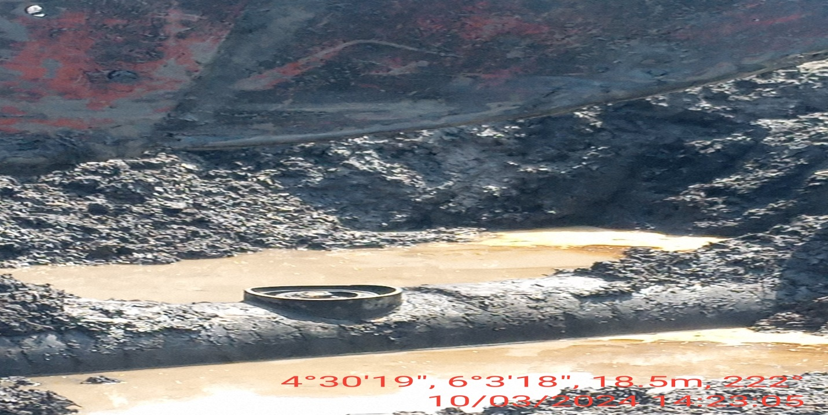
Fig. 1: The incident point at 12 O’ clock position.
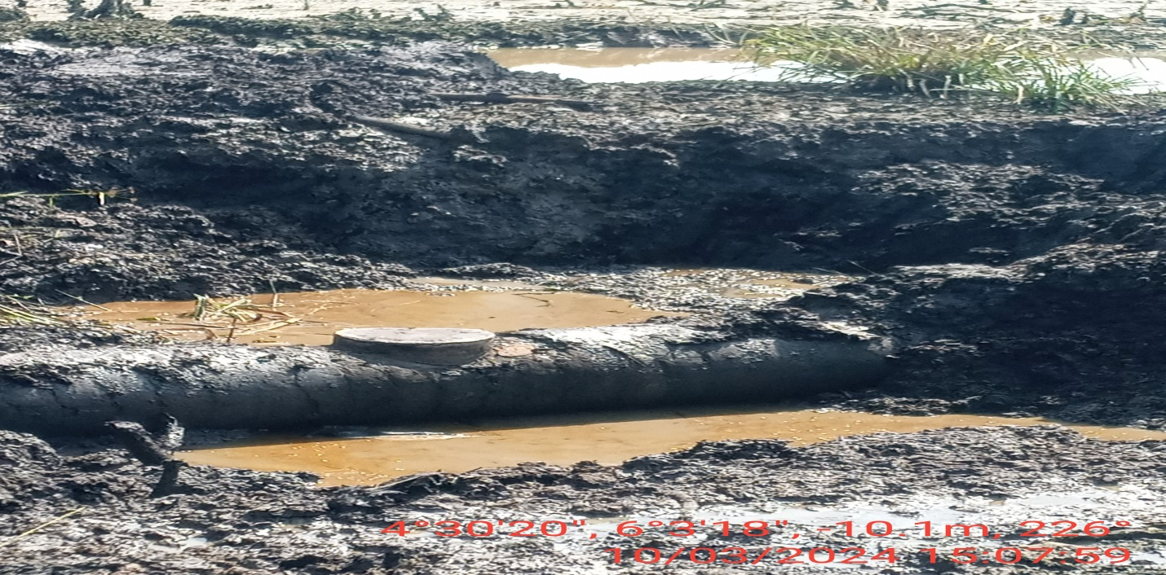
Fig. 2: The incident point after repairs has been done.

